Telos-USA & Mount Shasta Light Publishing Present

~ 2020 Initiatic Journey® ~

August 23 – August 29, 2020

With

Channel Bryan Tilghman and Guest Channel Dianne Robbins
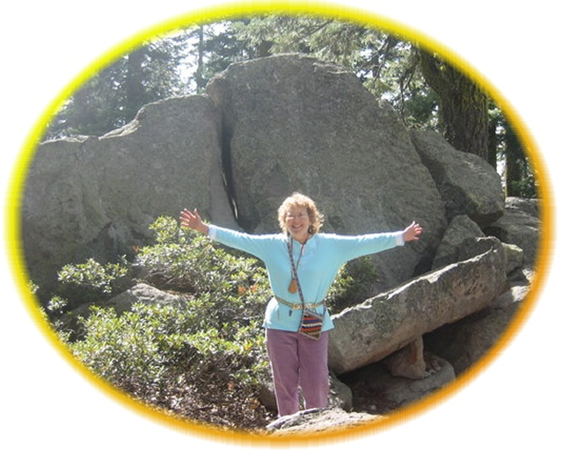

PERSONAL INFORMATION (Please print )

Name: First Last

Complete Address:

Zip Code / Country:

Phone Numbers: Home Cell:

Email:

Emergency Contact: In case of emergency, please identify the person(s) to be contacted.

Name

Address

Phone numbers: Day Evening

Relationship

If you would like to attach a photograph, please do so, but it is not required.

By signing this document, I declare having read, understand and accept all the conditions explained in the following documents: Registration information, Itinerary, Code of Conduct, the Disclaimer.

Accepted payments: By Check or Credit card through PayPal

___Enclosed is my payment for $1100 by check or PayPal Receipt attached.

___Enclosed is my payment of $550 with balance of $550 due on June 1st, 2020.

PayPal Payments in $US only. PayPal address: telosusa1@gmail.com
You do not have to have a PayPal account to use your credit card.

I declare and acknowledge I understand the cancellation policy and applicable cancellation fees.

Signed: ____________________________________________

Payment must accompany registration to reserve your space.
Call 530-926-4599 for any questions or concerns.

Return your registration via email, fax, or postal mail and keep a copy for your records.

Email: mt.shastalight@gmail.com
Fax: 530-926-4159

Mailing address:

MSLPublishing and Telos-USA
P.O. Box 1509
Mount Shasta, CA 96067-1509

.
We look forward to sharing this journey with you in the Heart of Mount Shasta!

Telos-USA and Mount Shasta Light Publishing/Telos-The Lemurian Connection

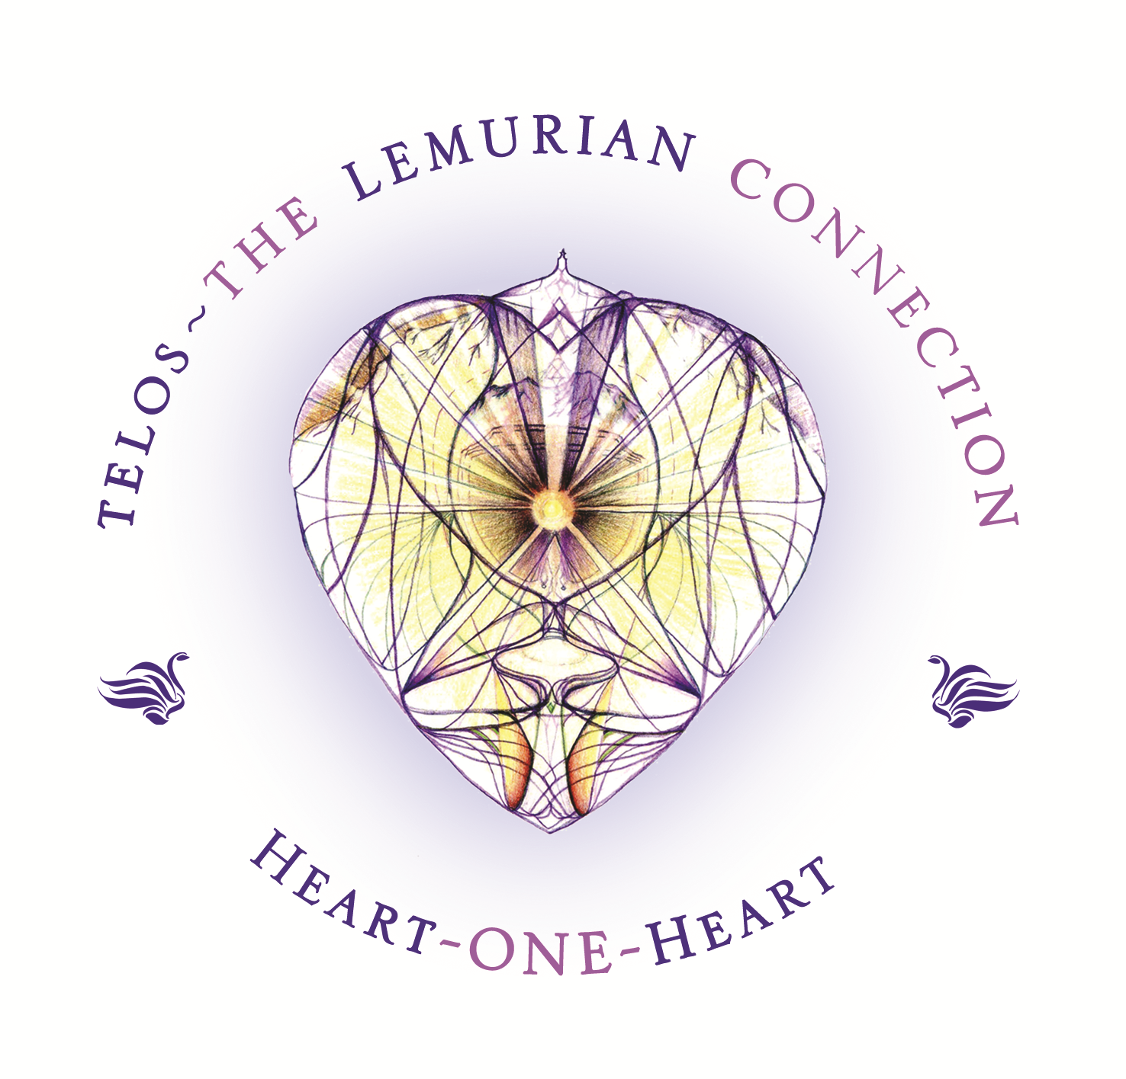

This information is the property of Telos-USA and Mount Shasta Light Publishing/Telos-The Lemurian Connection ® 2020. We do not share your information.

